Notice to Mariners

Vessels and General Safety Advice

**Scottish Hydro Electric Power Distribution (SHEPD)**

**Skye to South Uist Marine Surveys**

**Date of issue: 22/11/2024**

This Notice to Mariners supersedes that issued on 15th November 2024. Due to reduced scope of works remaining, the working corridor has been reduced accordingly. This NtM reflects these changes.

Please be advised that A-2-Sea Solutions Ltd (on behalf of SHEPD) are undertaking a marine survey within the cable corridors described below. Surveys will utilise vessel to complete survey operations:

* Mintaka I

Operations will have a planned minimum duration of 5 days, weather permitting.

Figure : Survey Area Skye to Loch Carnan on South Uist Survey Corridor

The Skye to Loch Carnan on South Uist operations will be concentrated across the cable corridor within the boundary defined by the following coordinates.

Table : Survey Area Skye to Loch Carnan on South Uist Survey Corridor

|  |  |  |  |
| --- | --- | --- | --- |
| **Survey Area Skye to Loch Carnan on South Uist 1100m Survey Corridor** | | | |
| Point | Datum | Latitude D D.M | Longitude D D.M |
| 1 | WGS84 | 57;28.13758N | 006;46.39677W |
| 2 | WGS84 | 57;28.12344N | 006;46.05094W |
| 3 | WGS84 | 57;27.95828N | 006;44.96558W |
| 4 | WGS84 | 57;27.77870N | 006;44.70420W |
| 5 | WGS84 | 57;27.58455N | 006;44.66385W |
| 6 | WGS84 | 57;27.56781N | 006;45.34302W |
| 7 | WGS84 | 57;27.63698N | 006;45.37186W |
| 8 | WGS84 | 57;27.75951N | 006;46.29968W |
| 9 | WGS84 | 57;27.40044N | 006;47.61234W |
| 10 | WGS84 | 57;26.84406N | 006;47.99396W |
| 11 | WGS84 | 57;26.83741N | 006;47.99879W |
| 12 | WGS84 | 57;26.47783N | 006;48.27444W |
| 13 | WGS84 | 57;26.16196N | 006;48.38894W |
| 14 | WGS84 | 57;25.82378N | 006;48.63814W |
| 15 | WGS84 | 57;24.72639N | 006;50.40971W |
| 16 | WGS84 | 57;24.37481N | 006;51.92599W |
| 17 | WGS84 | 57;24.25176N | 006;55.02794W |
| 18 | WGS84 | 57;23.40730N | 006;59.17710W |
| 19 | WGS84 | 57;23.17863N | 007;00.70463W |
| 20 | WGS84 | 57;21.51741N | 007;04.22665W |
| 21 | WGS84 | 57;21.28102N | 007;05.63065W |
| 22 | WGS84 | 57;21.03074N | 007;06.82180W |
| 23 | WGS84 | 57;20.86910N | 007;07.69903W |
| 24 | WGS84 | 57;21.04905N | 007;10.37518W |
| 25 | WGS84 | 57;21.33256N | 007;10.96453W |
| 26 | WGS84 | 57;21.38125N | 007;11.56717W |
| 27 | WGS84 | 57;21.35998N | 007;12.71977W |
| 28 | WGS84 | 57;21.38248N | 007;13.52250W |
| 29 | WGS84 | 57;21.77809N | 007;13.50841W |
| 30 | WGS84 | 57;21.77942N | 007;13.07416W |
| 31 | WGS84 | 57;21.73571N | 007;12.65162W |
| 32 | WGS84 | 57;21.75883N | 007;11.54278W |
| 33 | WGS84 | 57;21.68213N | 007;10.66304W |
| 34 | WGS84 | 57;21.41308N | 007;10.09287W |
| 35 | WGS84 | 57;21.24988N | 007;07.76490W |
| 36 | WGS84 | 57;21.38325N | 007;07.06985W |
| 37 | WGS84 | 57;21.63506N | 007;05.87142W |
| 38 | WGS84 | 57;21.85242N | 007;04.55986W |
| 39 | WGS84 | 57;23.52034N | 007;01.03721W |
| 40 | WGS84 | 57;23.76317N | 006;59.40886W |
| 41 | WGS84 | 57;24.62182N | 006;55.18028W |
| 42 | WGS84 | 57;24.74857N | 006;52.03687W |
| 43 | WGS84 | 57;25.03672N | 006;50.81957W |
| 44 | WGS84 | 57;26.01260N | 006;49.24842W |
| 45 | WGS84 | 57;26.25205N | 006;49.06884W |
| 46 | WGS84 | 57;26.59402N | 006;48.94152W |
| 47 | WGS84 | 57;26.97815N | 006;48.64783W |
| 48 | WGS84 | 57;27.66140N | 006;48.17509W |
| 49 | WGS84 | 57;28.13758N | 006;46.39677W |

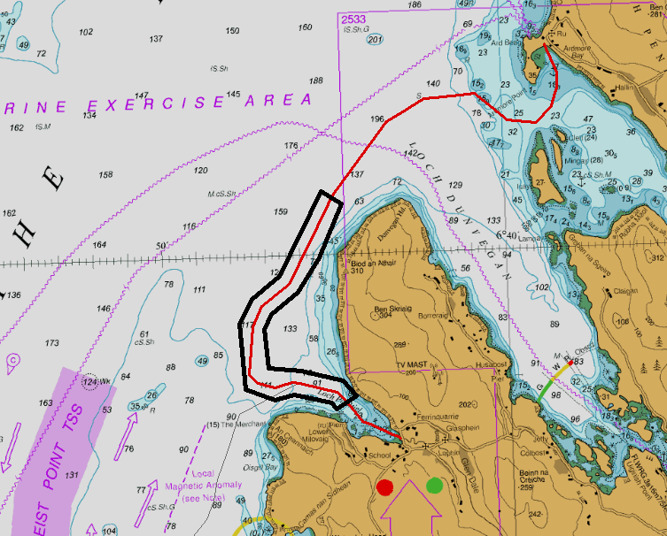

Figure : Survey Corridor Ardmore on Skye to Loch Pooltiel also on Skye

The Ardmore on Skye to Loch Pooltiel on Skye operations will be concentrated across the cable corridor within the boundary defined by the following coordinates.

Table : Survey Route Ardmore on Skye to Loch Pooltiel also on Skye

|  |  |  |  |
| --- | --- | --- | --- |
| **Survey Route Ardmore on Skye to Loch Pooltiel also on Skye 1100m Survey Corridor** | | | |
| Point | Datum | Latitude D D.M | Longitude D D.M |
| 1 | WGS84 | 57;30.776N | 006;44.743W |
| 2 | WGS84 | 57;29.949N | 006;45.443W |
| 3 | WGS84 | 57;29.422N | 006;46.083W |
| 4 | WGS84 | 57;29.089N | 006;46.877W |
| 5 | WGS84 | 57;28.859N | 006;47.097W |
| 6 | WGS84 | 57;28.246N | 006;47.019W |
| 7 | WGS84 | 57;28.18N | 006;46.056W |
| 8 | WGS84 | 57;28.011N | 006;44.879W |
| 9 | WGS84 | 57;27.775N | 006;44.503W |
| 10 | WGS84 | 57;27.574N | 006;45.086W |
| 11 | WGS84 | 57;27.673N | 006;45.23W |
| 12 | WGS84 | 57;27.823N | 006;46.288W |
| 13 | WGS84 | 57;27.744N | 006;46.867W |
| 14 | WGS84 | 57;27.918N | 006;47.705W |
| 15 | WGS84 | 57;28.952N | 006;47.817W |
| 16 | WGS84 | 57;29.332N | 006;47.441W |
| 17 | WGS84 | 57;29.677N | 006;46.626W |
| 18 | WGS84 | 57;30.983N | 006;45.331W |
| 19 | WGS84 | 57;30.776N | 006;44.743W |

The operations will be undertaken by the vessel Mintaka 1 pictured below. The vessel may operate primarily from Ullapool but may use other ports along the coastlines, such as Stornoway.

|  |  |
| --- | --- |
| **Vessel Photo** | **Vessel Description** |
| **A blue and yellow ship in the water  Description automatically generatedMintaka** | The Mintaka 1 is a multi-purpose survey vessel. 40 m in length with a beam of 6m and a draft of 2 m; transit speed of 12 kts and a survey speed of 4-6 kts. Operating on a 24-hour basis. Mintaka call sign is HO6142.  Contact: Vsat +31 223705008 / Mob: +48 602421456 |

**Survey Description**

The survey will involve collection of high-resolution geophysical seabed data and In-situ geotechnical sediment testing.

Other vessels should maintain an appropriate and safe distance of 500 m when passing the Mintaka 1 vessel whilst undertaking operations and should pass at the lowest possible speed to avoid vessel wash effects. The vessel(s) will be working 24-hour operations and will display appropriate day shapes and lights during reduced visibility and night operations. The vessel will also monitor VHF Channels 16 and 12.

**Primary Survey Equipment**

|  |  |  |  |
| --- | --- | --- | --- |
| Primary equipment | Towed,  Hull mounted,  Sampling | Approximate tow  length (if applicable) | Vessel |
| Multibeam Echosounder | Hull mounted | N/A | Mintaka |
| Sidescan Sonar | Towed | 50-600m | Mintaka |
| Magnetometer Array | Towed | 50-600m | Mintaka |
| Sub bottom Profiler | Hull mounted | N/A | Mintaka |
| Grab sampler | Sampling | N/A | Mintaka |
| Drop Down Video | Towed | 50-100m | Mintaka |
| CPT | Sampling | N/A | Mintaka |
| Vibrocore | Sampling | N/A | Mintaka |

**Contact Details**

The vessel contact details are given in the tables below

|  |  |
| --- | --- |
| VESSEL 1- Mintaka | |
| Call sign | HO6142 |
| Bridge | Telephone Number: +31 (0) 223 705 008 (Sat) |
| Offshore manager / Party Chief | Tudor Sartain |
| Email | Gavin.loveridge@a2sea.co.uk |
| Onshore Site Manager | Gavin Loveridge |

**Fisheries Liaison Officers**

Fishing liaison for the operations will be co-ordinated by Blackhall & Powis Ltd. For any commercial fishery queries please contact the Company Fishing Liaison Officers (CFLOs) :

Tommy Finn 07787 503119 tommy.finn@blackhallpowis.com

The local Fishing Industries Representative (FIR) will also be in place to liaise with the vessels and fishing operations in the survey area.

Ewen Grant 07990 506846 ewen@ewengrant.com

**Further Details**

Further enquiries should be addressed to the following people in the following order:

|  |  |  |
| --- | --- | --- |
| **Name** | **Contact Number** | **Email** |
| Christopher Briggs | +44(0) 1794 830 909 (Office) | Chris.briggs@a2sea.co.uk |
| Liam Flynn | +44(0) 1794 830 909 (Office) | Liam.flynn@a2sea.co.uk |

**Distribution List**

Any stakeholders identified within the relevant Fishing Liaison Management Action Plan (FLMAP), will be included on the distribution list for this NtM.

**Legal Notice**

Please be advised that this Notice to Mariners should be treated as official notice of the nature, duration and location of the works which are scheduled to take place. During the period of this notice, we request that you plan your activities around our short-term, temporary activities.

Any failure to remove equipment or entry into the identified location in a manner that would constitute a hazard would be a breach of your duties of safe seamanship as described in the Convention on International Regulations for Preventing Collisions at Sea 1972 and/or the Merchant Shipping Act 1995 and may result in removal of the relevant equipment. Failure to remove equipment or entry into the identified location in a manner that would constitute a hazard may constitute a breach of duty of care at common law, and a failure to protect submarine cables for successful seabed user co-existence under Scotland's National Marine Plan.