Legionnaires Disease Risk Assessment & Guidelines for Short-term lets
Who can carry out an assessment?
Landlord / hosts (including short-term let operators) , property owners and letting agents can carry out a Legionnaire’s risk assessment themselves if the property is a single dwelling or a flat with its own water supply (hot and cold) and they are competent to do so. In particular Landlord / hosts should:
- understand different types of water systems
- understand Legionella bacteria and the factors which increase the risk of an outbreak in a domestic setting
- understand the control measures which if present will reduce the risk of an outbreak within a domestic setting

Before considering carrying out a risk assessment you should familiarise yourself in particular with the following HSE publications: -
Legionella and Landlord / hosts’ responsibilities - www.hse.gov.uk/legionnaires/legionella-Landlord / hosts-responsibilities.htm
Legionnaire’s disease: A brief guide for duty holders - www.hse.gov.uk/pubns/indg458.pdf
The control of legionella bacteria in hot and cold water systems HSG247 - www.hse.gov.uk/pubns/priced/hsg274part2.pdf
Hot and cold water - Things to consider.- www.hse.gov.uk/legionnaires/assets/docs/hot-cold-legionella-checks.pdf

If you do not consider that you are competent then give the task to someone who is.

The risk assessment process
The practical risk assessment should include a site survey of the water system. A template is attached which is suitable for a basic system and can be adapted as required. The assessor should complete all the sections.

The assessor should understand the water systems and any associated equipment in the property, in order to conclude whether the system is likely to create a risk from exposure to Legionella.

It is important to identify whether:
- water is stored or re-circulated as part of the system (areas of risk include water tanks, dead legs, shower heads and/or long runs of pipe work containing warm water)
- the water temperature in some or all parts of the system is between 20 – 45°C (hot water should be stored in any tanks at 60°C)
- there are sources of nutrients such as rust, sludge, scale and organic matters
- conditions are present to encourage bacteria to multiply
- it is possible for water droplets to be produced and, if so, whether they could be dispersed, e.g. showers
- there are parts of the system that are used infrequently e.g. guest bathrooms
- it is likely that any of the tenants, residents, visitors etc are more susceptible to infection due to age, health or lifestyle and whether they could be exposed to any contaminated water droplets

Reviewing the risk assessment
If the risk assessment concludes there is no reasonably foreseeable risk or the risks are insignificant and are managed properly to comply with the law, the assessment is complete. Although no further action may be required at this stage, existing controls must be maintained. The assessment of risk is an ongoing process and not merely a paper exercise. The assessment should be reviewed regularly and specifically when there is reason to suspect it is no longer valid. The attached advice leaflet should be given to tenants.

Unoccupied /short term let properties
Hosts and any person employed to service the let should carry out regular checks the water systems between lets and including ensuring:
- the hot water temperature is not below 50°C or the hot water tank/boiler is not defective in any way
- the temperature of the hot water has not been adjusted
- the cold water is not obviously “warm” ( above 20°C)
- little used outlets are flushed through for 5 minutes at least changeover (turn the water on slowly so that it doesn’t splash, releasing water droplets into the air and then run at a flow rate that does not cause aerosols)
- shower heads are cleaned, disinfected and descaled at least once every 6 months
- they take remedial action if they notice any debris or discolouration in the hot or cold water

Outlets on hot and cold water systems should be used at least once a week to maintain a degree of water flow and minimise the chances of stagnation. To manage the risks during non-occupancy, consider implementing a suitable flushing regime or other measures, such as draining the system if the dwelling is to remain vacant for long periods. It is recommended that you keep a note of when you have had to flush the system as part of your maintenance records.

Guests Guide to Legionnaire’s Disease

What is Legionella?
Legionella is a bacteria that is naturally occurring in water sources such as lakes, reservoirs and ponds. It can enter the water systems within houses through the mains supply and given the right conditions, can begin to proliferate and potentially pose a threat.

Is it harmful?
Although naturally occurring and present in low levels in a lot of water sources, the bacteria is usually not harmful if ingested, but if the bacteria is spread through an aerosol (a garden hose or shower head) and comes into contact with a susceptible person, it is possible that they could contract Legionnaires’ disease.

What is Legionnaire’s disease?
Legionnaires' disease is a potentially fatal form of pneumonia caused by the inhalation of small droplets of contaminated water containing Legionella. Legionnaires’ disease is often mistaken for other diseases that affect the lungs, like pneumonia and the only way to get a definite diagnosis is through tests like blood and urine.

Where is Legionella found?
Hot and cold water systems in residential properties are a potential source for legionella bacteria growth. The main areas of risk are where the bacteria can multiply and increase to dangerous levels and then spread, e.g. in spray from showers and taps, even in dishwasher and washing machine pipes.

Conditions ripe for colonisation are where water of between 20°C and 45°C stagnates, and where there is sludge, rust and scale present for the bacteria to feed upon and multiply.

Who is at risk?
Legionnaire’s disease most commonly affects the elderly, or people with chest or lung problems. Not everyone exposed to legionella bacteria becomes ill.

Legionnaire’s disease is not contagious and you cannot get it from drinking water.

Legionella Risk Assessment
The risk from exposure to legionella has been assessed for the premises and it has been determined that there is minimal risk. The premises are maintained as necessary to ensure risks remain minimised.

What precautions can I take?
Taking the following simple precautions will help keep you safe:
- Inform your host if you believe the hot water temperature is below 50°C or the hot water tank/boiler is defective in any way
- Do not adjust the temperature of the hot water
- Advise your host if you believe the cold-water temperature is above 20°C
- Notify your host if you notice any debris or discolouration in the hot or cold water

Hosts should have this information available as part of their information pack

Examples of water systems
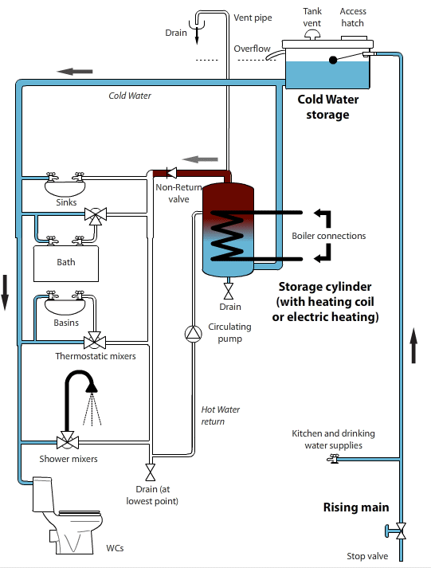 | 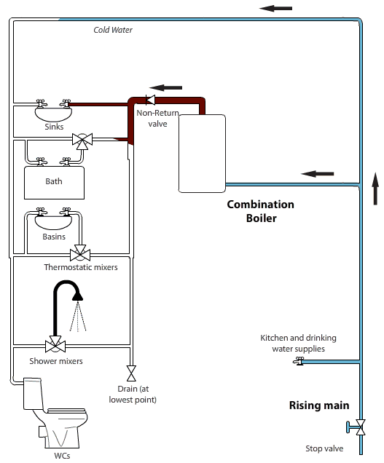
Hot & cold water storage – gravity fed system- www.hse.gov.uk/legionnaires/hot-and-cold-water-storage.htm | Pressurised mains-fed water system - www.hse.gov.uk/legionnaires/mains-pressure.htm
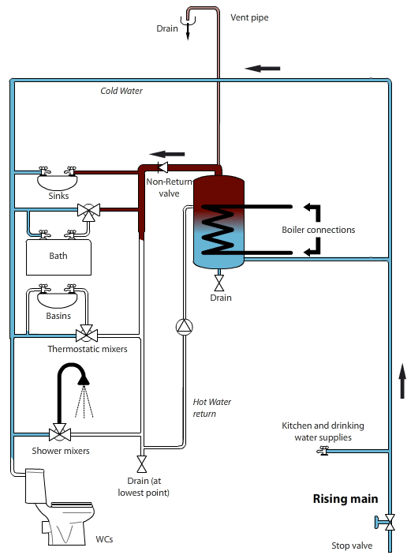 | 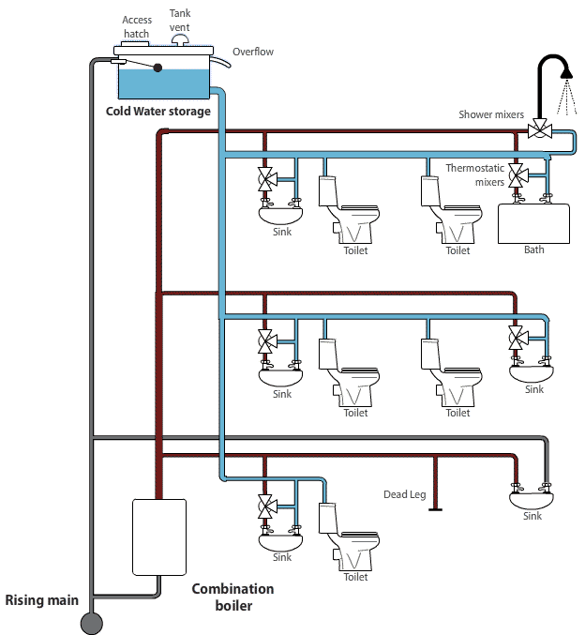
Pressurised mains-fed water system - www.hse.gov.uk/legionnaires/mains-pressure.htm | Cold water storage only – mains pressure hot water system - www.hse.gov.uk/legionnaires/cold-water-storage.htm

Legionnaires Disease Risk Assessment
Property address

Date of assessment |  |  | Assessment carried out by

Describe property type | Detached house | ☐ | Single flat | ☐ | Other

Are any guests tenant, resident or regular visitor particularly susceptible to Legionella due to age, health or lifestyle? | Yes

Describe type of cold-water system e.g.
mains feed or from storage tank
(Include sketch if possible at rear of document)

Describe type of hot water system e.g. mains feed via combi boiler or from storage tank.
(Include sketch if possible at rear of document)
RISK CATEGORIES
If you answer YES to any of the questions, please complete risk/recommendation

Water outlet temperature
Is cold water temperature at outlets below 20°C? | Yes | ☐ | No | ☐ | Is the hot water temperature above 50°C at outlets? | Yes | ☐ | No | ☐
Cold water must flow from outlets at below 20°C & hot water above 50°C to minimise risk. If thermostatic mixer valves (TMV's) are fitted, measure temperature at the hot water inlet to the TMVs. If temperatures are too low/high then adjustments need to be made to the system i.e. lagging of pipework or adjustment of temperature settings for hot water.
Identify any Defect/Risk

Related Recommendation

Responsible person to carry out action | Landlord / host | ☐ | Other | ☐ | Other  Details:

Cold water storage tanks
Is there a cold water storage tank present? | Yes | ☐ | No | ☐ | If No go to Q3 | Does it have a tight fitting lid? | Yes |  | No

Is the water temperature in the tank below 20°C? | Yes | ☐ | No | ☐ | Is water in the tank clean & free of rust, debris, scale & organic matter? | Yes |  | No

Is the tank insulated? | Yes | ☐ | No | ☐ | Location of tank
If any debris etc. is present in the system it should be drained & thoroughly cleaned. If debris is from corrosion on the tank itself then the tank may need to be replaced. All cold water tanks should have tight fitting lids to prevent debris entering the system. Water in the tank should be below 20°C & the tank insulated to prevent the temperature rising above this level.
Identify any Defect/Risk

Related Recommendation

Responsible person to carry out action | Landlord / host | ☐ | Other | ☐ | Other  Details:

Hot water
Is the temperature setting on the boiler and/or hot water tank such that  the hot water is heated to and stored at a temperature of 60°C? | Yes | ☐ | No | ☐
NB: If the temperature is set at above 60°C this can cause scalding to users. The temperature setting on the boiler and/or hot water tank should be set and maintained at 60°C or above.
Identify any Defect/Risk

Related Recommendation

Responsible person to carry out action | Landlord / host | ☐ | Other | ☐ | Other  Details:

Little used outlets
Are there any water outlets that are used less than once per week e.g. in guest bathrooms? If yes, identify outlet & location below | Yes | ☐ | No | ☐
Any little used outlets should be flushed through weekly by running water through the outlet for at least 5 minutes. Aerosol production should be minimised during this process. It is better to run the water longer at a lower pressure to avoid aerosols.
Identify any Defect/Risk

Related Recommendation

Responsible person to carry out action | Landlord / host | ☐ | Other | ☐ | Other  Details:

Shower heads
Are there any showers in the property? If yes, identify outlet & location below | Yes | ☐ | No | ☐
Shower heads should be cleaned, disinfected and descaled at least once every 6 months. Aerosol production should be minimised during this process.
Identify any Defect/Risk

Related Recommendation

Responsible person to carry out action | Landlord / host | ☐ | Other |  | Other  Details:

Dead legs and redundant pipework
Sections of pipework which are redundant or owing to the system design & have little/no through flow of water (known as “dead legs”) can allow water to stagnate in the system. Are there any dead legs known in the system?
Are there any dead legs in the property? If yes, identify outlet & location below | Yes | ☐ | No | ☐
Any dead legs in pipework should be removed or the system altered so that water flows through all pipework regularly.
Identify any Defect/Risk

Related Recommendation

Responsible person to carry out action | Landlord / host | ☐ | Tenant | ☐ | Other | ☐ | Other  Details:

Unoccupied properties
Is the property left unoccupied for periods of time, e.g. in the case of student or guests lettings over the summer holiday or at Christmas/New Year | Yes | ☐ | No | ☐
All hot & cold water outlets should be flushed through at least once a week for at least 5 minutes when unoccupied & prior to re-occupation. Aerosol production should be minimised during this process If empty long term - consider draining the system.
Identify any Defect/Risk

Related Recommendation

Responsible person to carry out action | Landlord / host | ☐ | Tenant | ☐ | Other | ☐ | Other  Details:

Advice to tenants (This can be done by giving the tenant/s the tenant advice sheet)
Has advice been given to the tenants as to the risks of Legionnaires?  Disease in a domestic setting and their responsibilities to minimise risk? | Yes | ☐ | No | ☐ | N/A as Short term lets

The assessment is complete and should be reviewed at least annually or if any information changes. You should ensure that the recommendations above are implemented and any existing controls maintained.
Signed |  | Date
Print Name

Diagram/Sketch of Water System In Property
(You can use any of the examples provided within this form if they meet your requirements)
(Include all pipework water storage tanks, taps outlets and showers)

Legionnaire’s Disease Risk Assessment Review - To be completed at least once per year.
Property address

Date of assessment |  | Assessment carried out by

Since the original risk assessment was carried out: -
Has there been a change to the water system or the way it is used by occupants? | Yes | ☐ | No | ☐

Has there been a change to the use of the building where the system is installed? | Yes | ☐ | No | ☐

Is there new information available about risks or control measures? | Yes | ☐ | No | ☐

When testing the temperature of the water in the system, does hot water flow from any outlets at a temperature of below 50C? | Yes | ☐ | No | ☐

When testing the temperature of water in the system, does cold water flow from any outlets at a temperature of above 20C? | Yes | ☐ | No | ☐

Are the current tenants and their visitors more susceptible due to their age, health or lifestyle? | Yes | ☐ | No | ☐

Has there been a case of Legionnaires Disease associated with the system? | Yes | ☐ | No | ☐

If you have answered yes in response to any of the questions above, a new risk assessment should be carried out by a competent person.

Signed |  | Date
Print Name

-------------------------------------------------------------------------------------------------------------------------------------------------------------
Property address

Date of assessment |  | Assessment carried out by

Since the original risk assessment was carried out: -
Has there been a change to the water system or the way it is used by occupants? | Yes | ☐ | No | ☐

Has there been a change to the use of the building where the system is installed? | Yes | ☐ | No | ☐

Is there new information available about risks or control measures? | Yes | ☐ | No | ☐

When testing the temperature of the water in the system, does hot water flow from any outlets at a temperature of below 50C? | Yes | ☐ | No | ☐

When testing the temperature of water in the system, does cold water flow from any outlets at a temperature of above 20C? | Yes | ☐ | No | ☐

Are the current tenants and their visitors more susceptible due to their age, health or lifestyle? | Yes | ☐ | No | ☐

Has there been a case of Legionnaires Disease associated with the system? | Yes | ☐ | No | ☐

If you have answered yes in response to any of the questions above, a new risk assessment should be carried out by a competent person.

Signed |  | Date
Print Name

-------------------------------------------------------------------------------------------------------------------------------------------------------------
Property address

Date of assessment |  | Assessment carried out by

Since the original risk assessment was carried out: -
Has there been a change to the water system or the way it is used by occupants? | Yes | ☐ | No | ☐

Has there been a change to the use of the building where the system is installed? | Yes | ☐ | No | ☐

Is there new information available about risks or control measures? | Yes | ☐ | No | ☐

When testing the temperature of the water in the system, does hot water flow from any outlets at a temperature of below 50C? | Yes | ☐ | No | ☐

When testing the temperature of water in the system, does cold water flow from any outlets at a temperature of above 20C? | Yes | ☐ | No | ☐

Are the current tenants and their visitors more susceptible due to their age, health or lifestyle? | Yes | ☐ | No | ☐

Has there been a case of Legionnaires Disease associated with the system? | Yes | ☐ | No | ☐

If you have answered yes in response to any of the questions above, a new risk assessment should be carried out by a competent person.

Signed |  | Date
Print Name

-------------------------------------------------------------------------------------------------------------------------------------------------------------
Property address

Date of assessment |  | Assessment carried out by

Since the original risk assessment was carried out: -
Has there been a change to the water system or the way it is used by occupants? | Yes | ☐ | No | ☐

Has there been a change to the use of the building where the system is installed? | Yes | ☐ | No | ☐

Is there new information available about risks or control measures? | Yes | ☐ | No | ☐

When testing the temperature of the water in the system, does hot water flow from any outlets at a temperature of below 50C? | Yes | ☐ | No | ☐

When testing the temperature of water in the system, does cold water flow from any outlets at a temperature of above 20C? | Yes | ☐ | No | ☐

Are the current tenants and their visitors more susceptible due to their age, health or lifestyle? | Yes | ☐ | No | ☐

Has there been a case of Legionnaires Disease associated with the system? | Yes | ☐ | No | ☐

If you have answered yes in response to any of the questions above, a new risk assessment should be carried out by a competent person.

Signed |  | Date
Print Name

